**Heat Map Showing the Location and Humidity for Sampled Cities** (more cities than shown are included)

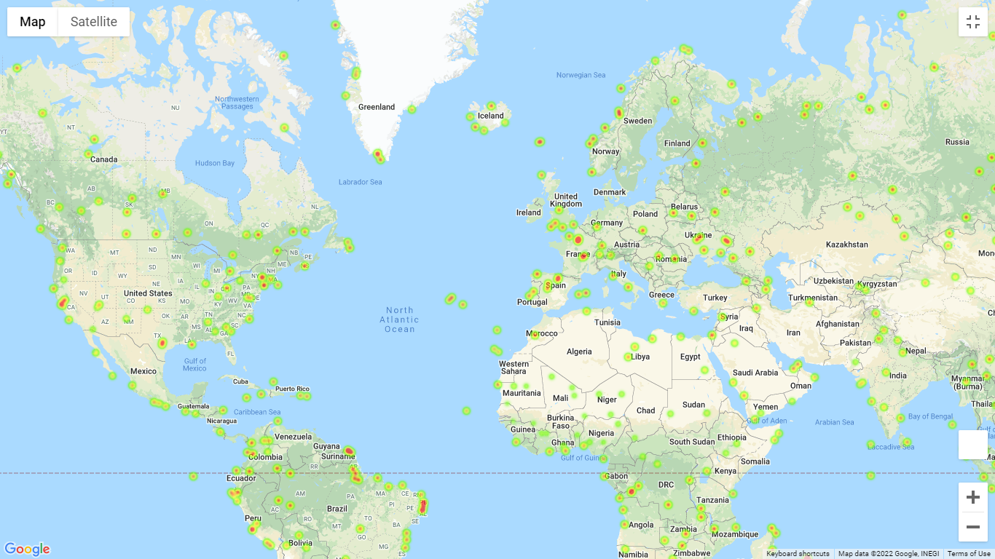

**Marker Layer Showing the Cities with Ideal Weather and their Hotel Locations**

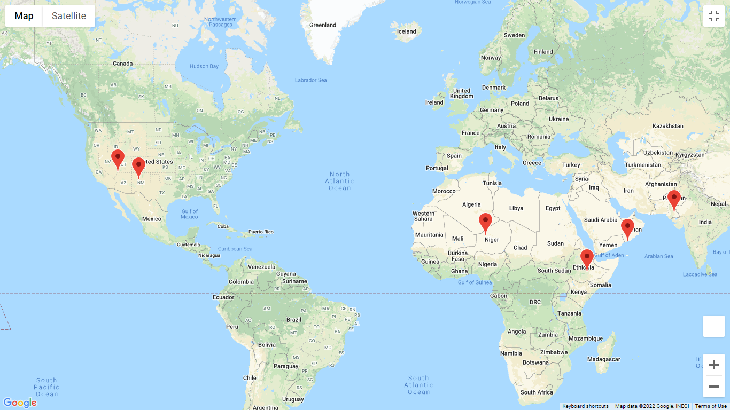

**Combined Heat Map and Marker Layer Map** (more cities than shown are included)

